- Click on Admintration -> Integrations -> Outgoing Webhooks
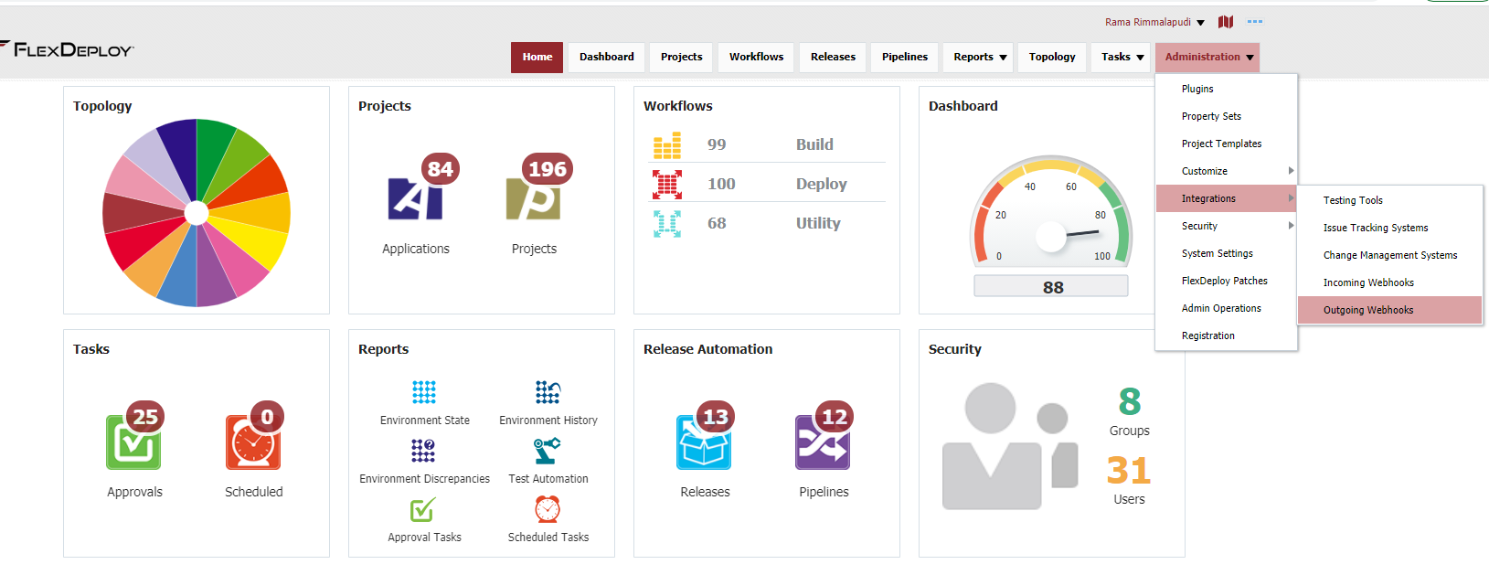
- Click on Create Listener
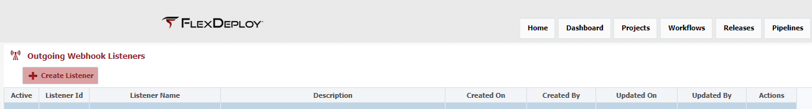
- On this page enter following and click save.
  - Listener Name as SaveExecutionLogs
  - Select Workflow Completed checkbox
  - On the filter enter following test
  - return EVENT.payload.project.projectName.contains('Code Scanner');
  - On the Script tab replace the code with below code. Change the highlighted folder.
  - import flexagon.ff.adfext.common.model.pojos.communication.EmailAttachment;
  - import groovy.json.JsonOutput;

  - //Carry out any custom action you wish for this event. Check out the documentation for reference or ideas.
  - //Optionally filter out events you dont want to execute by returning false on the filter script tab.
  - def listenerName = "Email Failed Logs";
  - LOG.info("Running listener: ${listenerName}");

  - //retrieve plugin log input stream map
  - def logs = FLEXDEPLOY.getPluginLogInputStreams(EVENT.payload.workflowExecutionId);

  - logs.each { log ->
  - filename = "/tmp/logs/${log.key}.txt";
  - File file = new File(filename);
  - file.write(log.value.getText());
}

